**ZONION APP**

**Introduction:**

* Welcome to Zonions App. It’s an app to show all restaurants at one place just a click away.
* This app basically has two roles
  + A view only access to **Users**
  + **Admin** role to login, add, delete, edit, activate or deactivate restaurants

**Technology Stack:**

* Frontend: React.js
* Middleware: Node.js with Sails.js Framework
* Database: MongoDB

**Front End Work Flow**

* 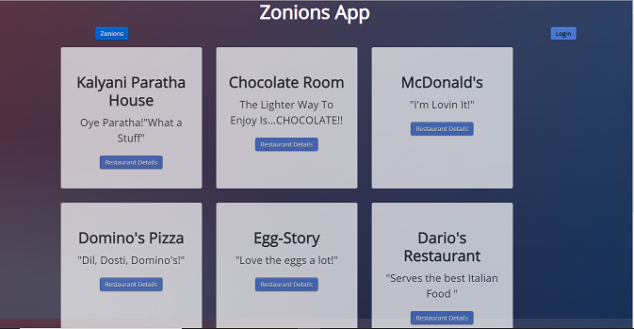**Home Page:** All the ‘active’ restaurants are shown here with their unique taglines
* 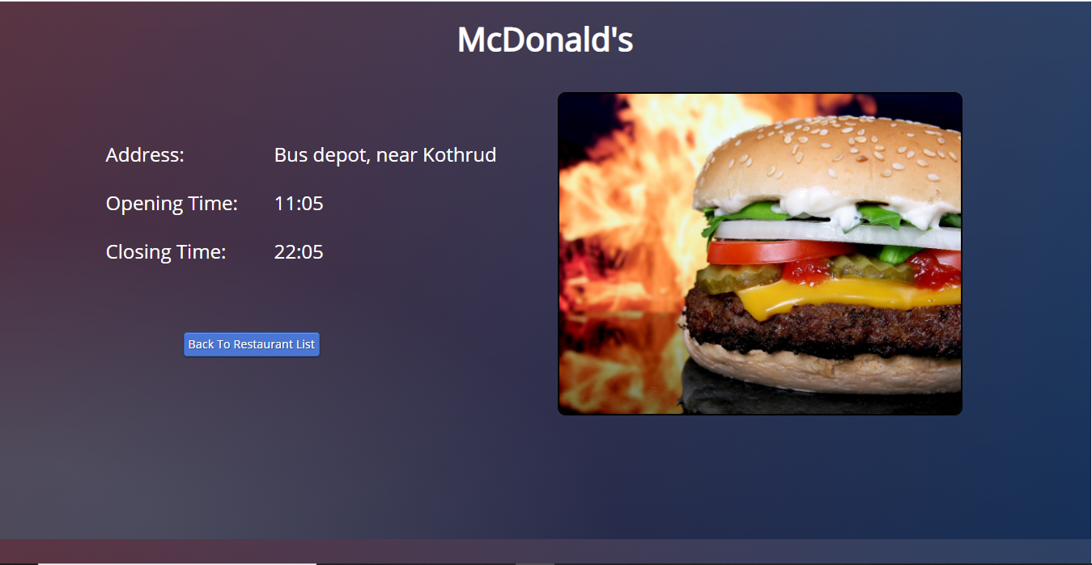**Restaurant Details Page:** When clicked on “Restaurant Details” button of home page, it shows complete details of that particular restaurant as below. On this page if clicked on “Back To Restaurant List” it will go back to ‘Home’ page.
* **Login Page:** On home page if clicked on “Login” button, it goes to login page where only admins can login.

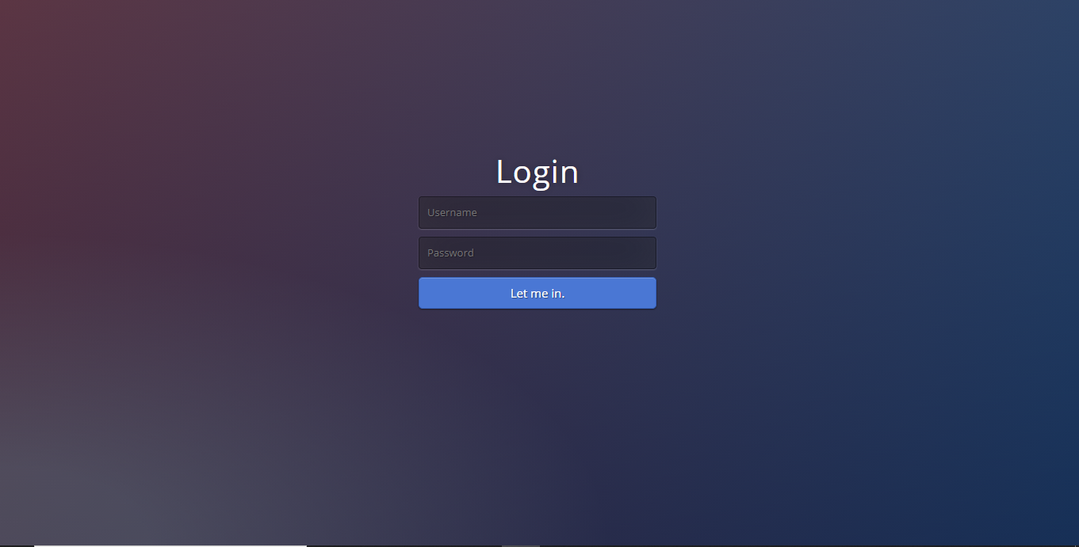

While login if the email and password did not match with admin it will show the errors

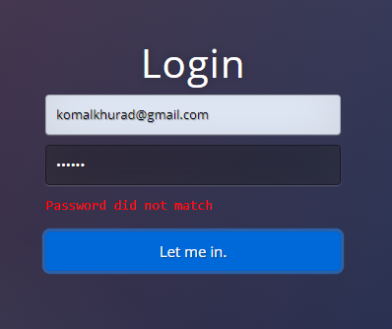

* **Manage Restaurant Page:** On successful login, manage restaurant page will be displayed with all the functionality to be performed by the admin

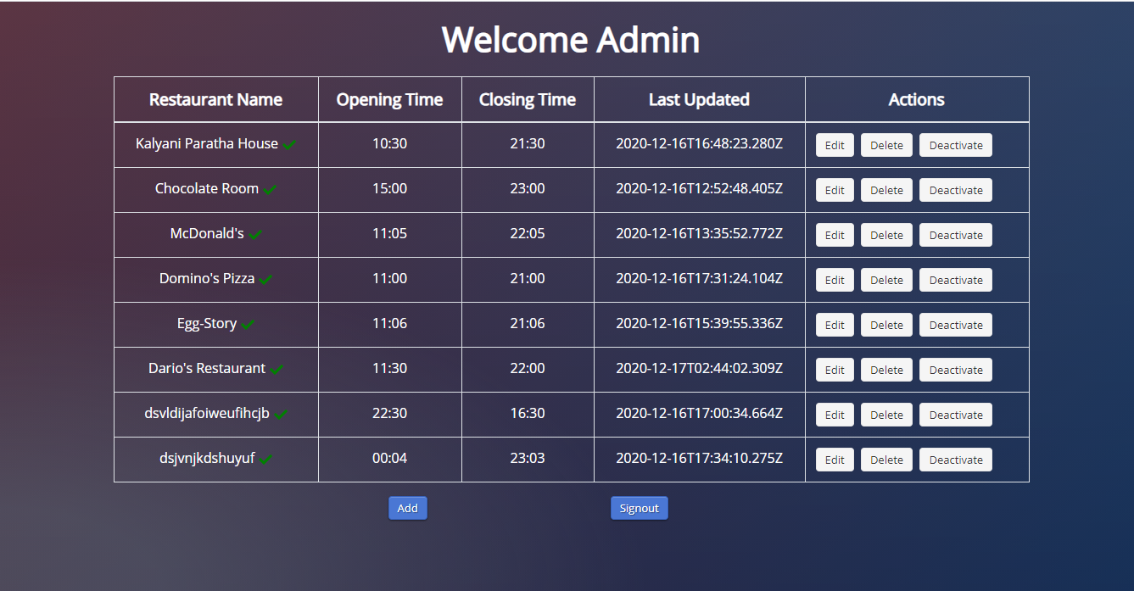

Here if clicked on “Delete” button, it will alert to check if surely wants to delete

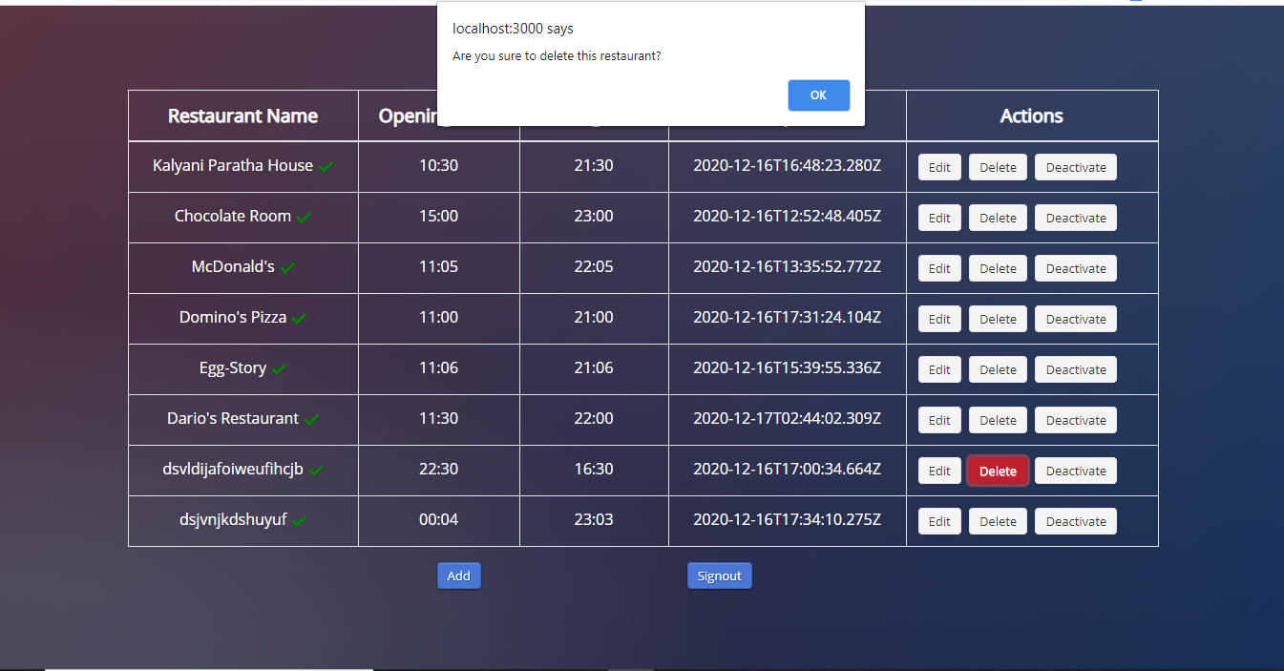And then delete the record of that restaurant from table and database.

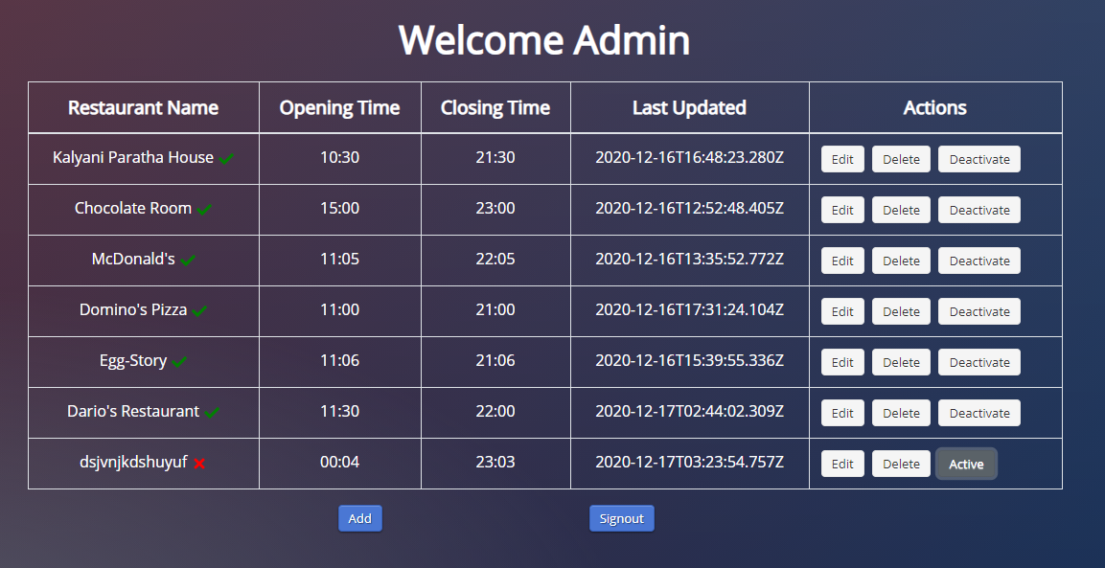If clicked on “Deactivate” button it will change the “green check” to “red cros” and “Deactivate” to “Active” and this deactivated restaurant will no more be shown on the home page.

* 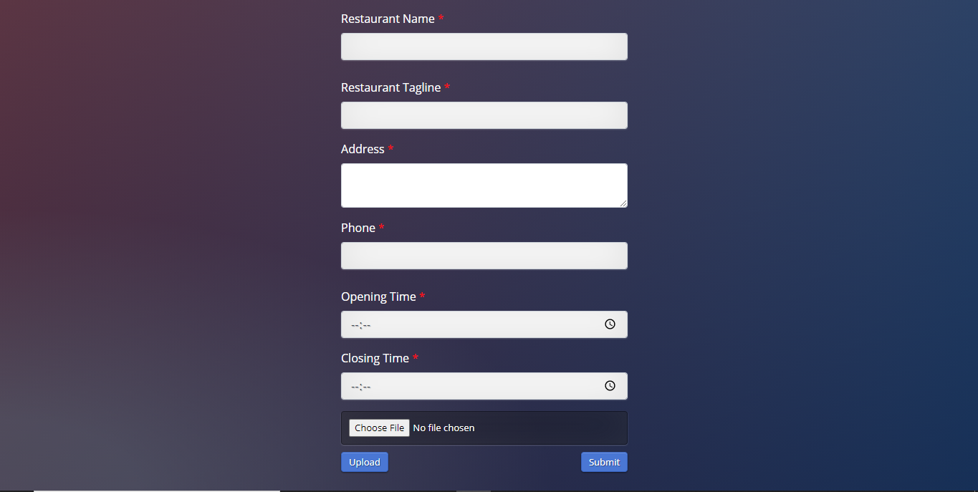**Add Restaurant:** On manage restaurant page if clicked of “Add” button, it goes to add restaurant page

This page validates each field for correct input:

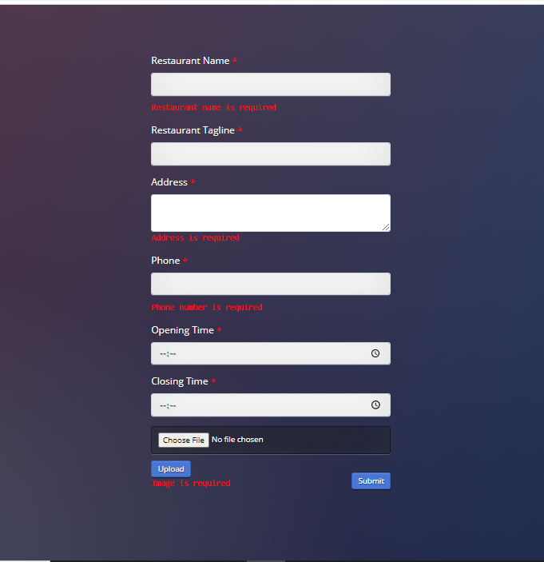

If all the data inserted correctly, it will go back to manage restaurant page.

* **Edit Restaurant Page:** On manage restaurant page, if clicked on “Edit” button it goes to edit page with all the previous data

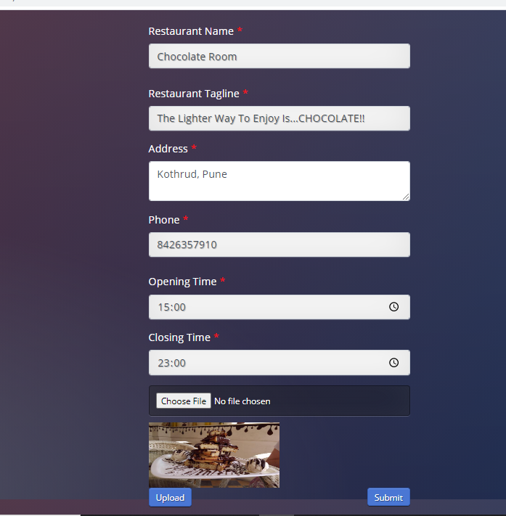After editing it goes back to manage restaurant page and then updates the last updated time.

If clicked on “Signout” button then admin will be alerted with successful sign out and page goes to home page.

**API Documentation**

* Used Sails.js for server side, with provides us with MVC structure, Water-line ODM.
* Made use of Controller and Model part and view is designed separately with React.js
* All the database configurations are made in ‘/config/datastores.js’ file.
* API end points are declared in the ‘/config/routes.js’ file.

Add Restaurant: ‘http://localhost:1337/restaurant/create

Get All Restaurant: ‘http://localhost:1337/restaurant/find

Get One Restaurant By Id : ‘http://localhost:1337/restaurant/find/:id

Update Restaurant: ‘http://localhost:1337/restaurant/update/:id

Delete Restaurant: ‘http://localhost:1337/restaurant/delete/:id

**Future Scope for Zonions App:**

* Search functionality for the user on home page so that they can search by food category(ex. South Indian Restaurants)
* Multiple Admin: We will create multiple admin functionality, their registration, login, JWT authorization and API for these t backend, create database collection for admin
* For each restaurant multiple menus, and multiple images will be included
* All the alerts will be converted into modals and toasts
* Works towards responsiveness and cover images